**Analysis and Visualization of the Dog Rating Tweet data**

## Motivation¶

WeRateDogs is a twitter account dedicated mostly on rating dogs picture on the internet. It has been a popular account, not only due to the dog picture it posted, but also because of the unique rating system that they are using. In this analysis, we are trying to gain interesting facts among the dogs captured in the tweets and also the result of the image prediction made from the dogs, which generates 3 most popular tags for each dogs.

### **Most popular dog name**

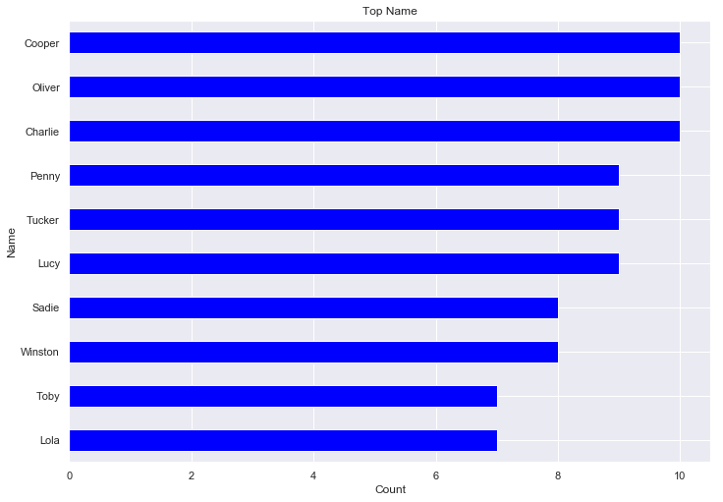

Seems like Cooper, Oliver and Charlie are the most popular dog names

### **Is there a correlation between retweet count and favorite count?**

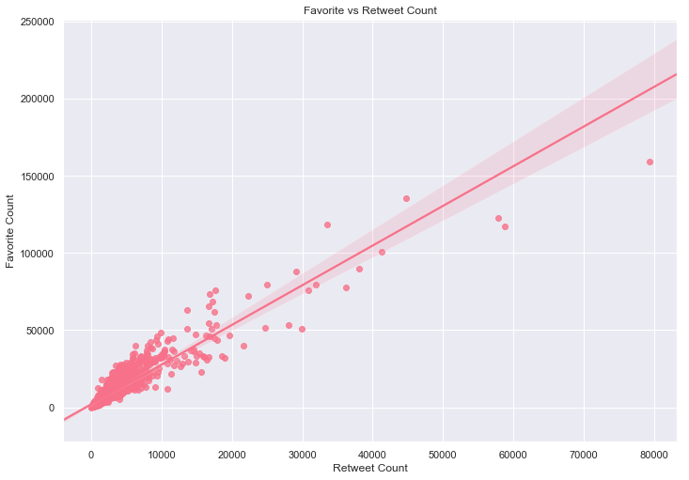

it seems like there is a positive correlation between favorite count and retweet count. The more favorite a tweet get, the more is it likely to be retweeted

### **Whether there is a relationship between time and rating**

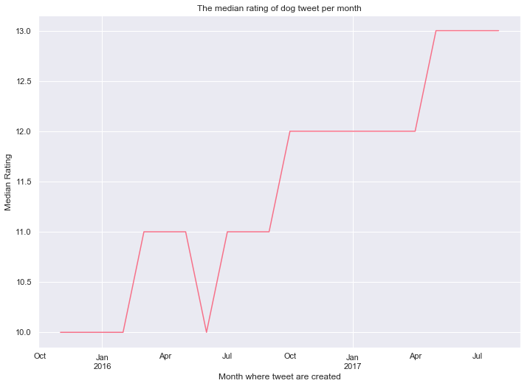

It seems like dog rating increases over time

#### **Confidence level of image prediction?**

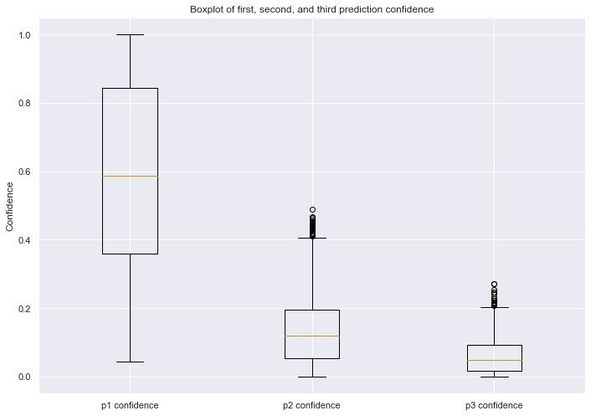

We can see that the first prediction tend to be significantly higher (i.e: more accurate) than the second and third prediction.

### **Does @weRateDogs tweets more dog rating as it gains popularity?**

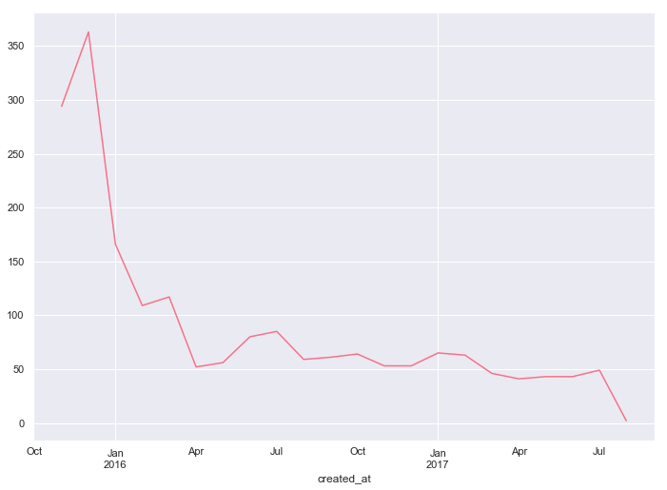

@weRateDogs does not become more active in rating dogs as the month goes by. In particular, the tweet count has the tendency to decrease.